July 2015 KENNEDY GALLERY
JAMES BOUVIER
bouvierj@sbcglobal.net
713 501 6640
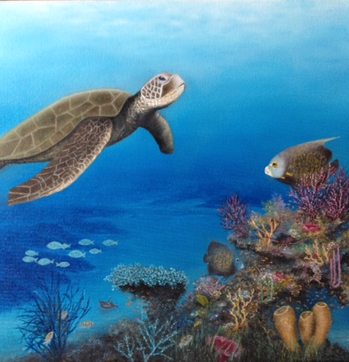
CRUISING THE CAYMANS 20X20 $500.00
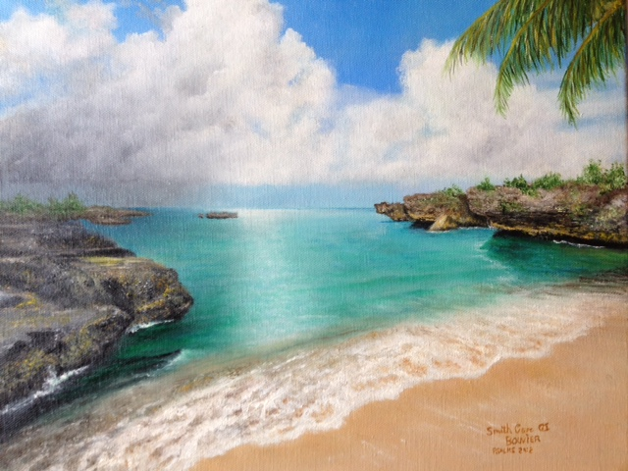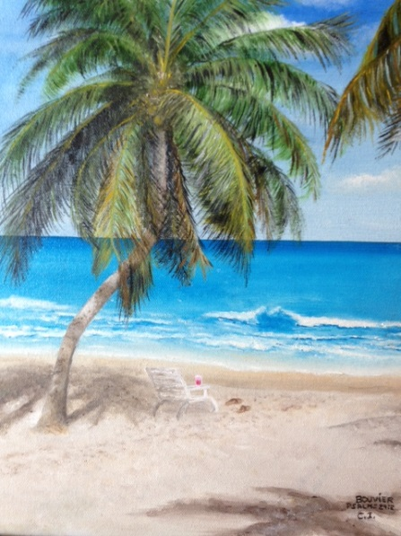
SMITH COVE 12X14 GONE FOR A SWIM 12X14
$400.00 $375.00

NOVEMBER , 2015
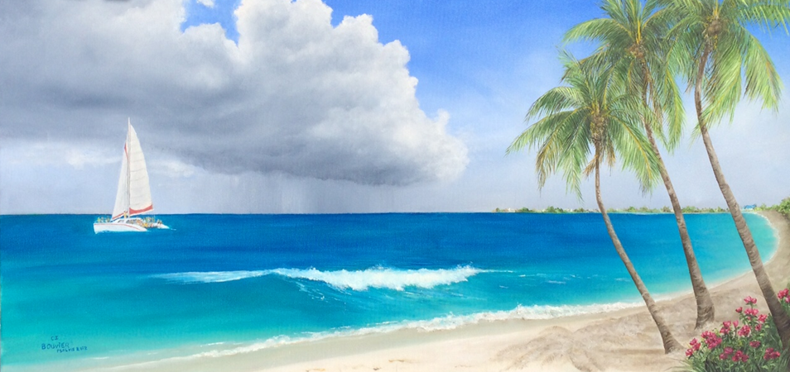
SAILING GRAND CAYMAN 18x36 $800.00

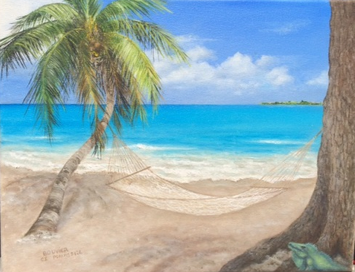
BLUE IGUANA 11X14 WAITING FOR WIND 12X16
$350.00 $450.00

